**LITHUANIA ENDOSCOPY DEVICES MARKET**

According to Intelli, the Lithuania endoscopy devices market was valued at USD 74.8 million in 2024 and is projected to reach USD 109.3 million by 2032, growing at a CAGR of 4.8% from 2025 to 2032.

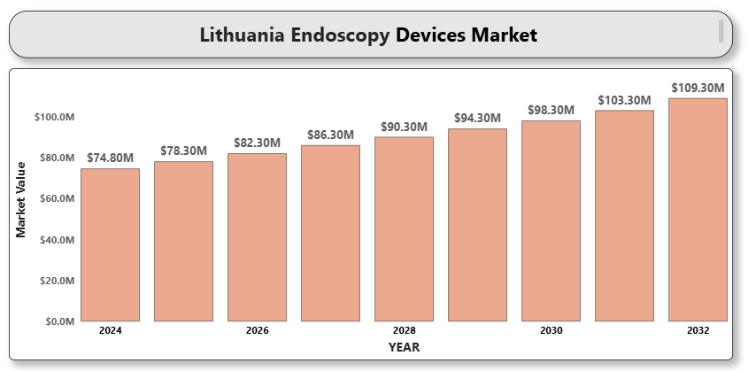

The market is driven by increasing prevalence of gastrointestinal disorders, the growing geriatric population, and rising demand for minimally invasive surgeries. Endoscopic procedures are gaining traction across Lithuanian healthcare institutions due to shorter recovery times, reduced post-operative complications, and cost-effectiveness.The Lithuanian government's support for healthcare digitization and the adoption of modern surgical equipment in hospitals is further accelerating the growth of the endoscopy devices market. Increasing awareness about colorectal cancer screening and preventive diagnostics also plays a crucial role in expanding endoscopic applications.

**Lithuania endoscopy devices market** **Market Definition**

Endoscopy devices are instruments used to examine the interior of hollow organs or cavities within the body using minimally invasive procedures. These include endoscopes, visualization systems, insufflators, operative devices, and related accessories.

In Lithuania, endoscopy devices are increasingly deployed across hospitals, diagnostic centers, and ambulatory surgical centers for applications in gastroenterology, urology, gynecology, pulmonology, and more. This widespread adoption is supported by a rising burden of chronic and age-related conditions that necessitate frequent internal examinations. With healthcare systems focusing on early detection and cost-efficient treatment modalities, the use of endoscopic technologies is expanding beyond traditional diagnostic purposes to include therapeutic and interventional procedures.

Additionally, government health initiatives aimed at increasing access to quality care and modern surgical methods are helping to standardize the use of endoscopy devices across urban and regional facilities. As Lithuania modernizes its health sector, the role of minimally invasive solutions like endoscopy is expected to deepen, ensuring timely diagnosis and improved patient outcomes across various clinical departments.

**Lithuania endoscopy devices market** **Market Overview**

The market is also witnessing rapid innovation in imaging technologies, disposable scopes, and AI-assisted endoscopic platforms, which are increasingly being integrated into clinical practice. Tele-endoscopy and remote training modules are gaining traction in rural healthcare facilities, helping address physician shortages and improve procedural access.

Moreover, government-backed screening programs, particularly for colorectal cancer, have significantly increased the volume of diagnostic endoscopic procedures, further stimulating demand for flexible endoscopes, video processors, and related accessories. These factors collectively position Lithuania as a steadily growing and attractive market for both global and regional endoscopy device manufacturers.

**Market Segment Analysis**

**By Product Type**

* **Endoscopes (Flexible, Rigid, Capsule)**
* **Visualization Systems (Cameras, Displays, Light Sources, Recorders)**
* **Operative Devices (Biopsy Forceps, Graspers, Snares, Scissors)**
* **Insufflators**
* **Accessories (Trocars, Cleaning Brushes, Tubing Sets)**

**By Application**

* **Gastrointestinal Endoscopy**
* **Laparoscopy**
* **Bronchoscopy**
* **Urology Endoscopy**
* **Gynecology Endoscopy**
* **Arthroscopy**
* **A close-up of hands holding a tablet and a pen

  Description automatically generatedOthers (ENT, Neurology)**

**By End User**

* **Hospitals and Clinics**
* **Ambulatory Surgical Centers (ASCs)**
* **Diagnostic Centers**

**Competitive Landscape**

The Lithuania endoscopy devices market is moderately fragmented, with a mix of international manufacturers and regional distributors. Key players are focusing on partnerships with local healthcare providers, training programs, and equipment leasing models to penetrate the market.

The competition is shaped by technological innovation, pricing strategies, and after-sales service. Sustainability and eco-friendly product offerings are emerging as differentiators.

**Company Profiles**

* Olympus Corporation
* Karl Storz SE & Co. KG
* Stryker Corporation
* Boston Scientific Corporation
* Medtronic plc
* FUJIFILM Holdings Corporation
* Richard Wolf GmbH
* Hoya Corporation (Pentax Medical)
* Smith & Nephew plc
* Cook Medical
* CONMED Corporation
* A close-up of hands holding a tablet and a pen

  Description automatically generatedB. Braun Melsungen AG
* Ambu A/S
* Arthrex, Inc.
* Xion Medical
* Henke-Sass, Wolf GmbH

**Key Developments**

* **In February 2024**, Olympus launched a new generation of flexible gastrointestinal endoscopes in Europe, enhancing precision and maneuverability.
* **In March 2024**, Karl Storz collaborated with Lithuanian hospitals to provide training workshops on advanced laparoscopy.
* **In April 2025**, FUJIFILM Healthcare Europe launched the ELUXEO® 8000, an advanced endoscopy system featuring enhanced therapeutic capabilities, improved image quality, and integrated workflow management. This marks the first release under the company’s ‘WELCOME, FUTURE’ initiative, signaling a new wave of innovative medical technologies.

**Market Attractiveness**

Lithuania offers a growing market for endoscopy devices due to increasing procedural volumes, improving healthcare access, and supportive health policies. Investments in hospital modernization and demand for preventive care create attractive opportunities for global and regional device manufacturers.

**Porter’s Five Forces Analysis**

* **A close-up of hands holding a tablet and a pen

  Description automatically generatedThreat of New Entrants:** Moderate – Capital requirements and regulatory approvals present entry barriers.
* **Bargaining Power of Suppliers:** Moderate – Technological differentiation among suppliers limits substitution.
* **Bargaining Power of Buyers:** High – Healthcare institutions seek affordable, reliable, and service-backed solutions.
* **Threat of Substitutes:** Low – Minimally invasive diagnostics and surgeries have few alternatives.
* **Competitive Rivalry:** High – Global giants compete with local distributors for market share.

**Table of Contents**

1. **Introduction of Lithuania Endoscopy Devices Market**
   * 1.1 Overview of the Market
   * 1.2 Scope of Report
   * 1.3 Assumptions
2. **Executive Summary**
3. **Research Methodology**
   * 3.1 Data Mining
   * 3.2 Validation
   * 3.3 Primary Interviews
   * 3.4 List of Data Sources
4. **Lithuania Endoscopy Devices Market Outlook**
   * 4.1 Overview
   * 4.2 Market Dynamics
     + 4.2.1 Drivers
     + 4.2.2 Restraints
     + 4.2.3 Opportunities
     + 4.2.4 Trends
   * 4.3 Porter’s Five Forces Model
   * 4.4 Value Chain Analysis
5. **Market, by Product Type**
   * 5.1 Endoscopes
   * 5.2 Visualization Systems
   * 5.3 Operative Devices
   * 5.4 Insufflators
   * 5.5 Accessories
6. **Market, by Application**
   * 6.1 Gastrointestinal Endoscopy
   * 6.2 Laparoscopy
   * 6.3 Bronchoscopy
   * A close-up of hands holding a tablet and a pen

     Description automatically generated6.4 Urology Endoscopy
   * 6.5 Gynecology Endoscopy
   * 6.6 Arthroscopy
   * 6.7 Others
7. **Market, by End User**
   * 7.1 Hospitals and Clinics
   * 7.2 Ambulatory Surgical Centers
   * 7.3 Diagnostic Centers
8. **Competitive Landscape**
   * 8.1 Overview
   * 8.2 Company Market Ranking
   * 8.3 Key Development Strategies
9. **Company Profiles**

**9.1 Olympus Corporation**  
9.1.1 Overview  
9.1.2 Financial Performance  
9.1.3 Product Outlook  
9.1.4 Key Developments

**9.2 Karl Storz SE & Co. KG**  
9.2.1 Overview  
9.2.2 Financial Performance  
9.2.3 Product Outlook  
9.2.4 Key Developments

**9.3 Stryker Corporation**  
9.3.1 Overview  
9.3.2 Financial Performance  
9.3.3 Product Outlook  
9.3.4 Key Developments

**9.4 Boston Scientific Corporation**  
9.4.1 Overview  
9.4.2 Financial Performance  
9.4.3 Product Outlook  
9.4.4 Key Developments

**9.5 Medtronic plc**  
9.5.1 Overview  
9.5.2 Financial Performance  
9.5.3 Product Outlook  
9.5.4 Key Developments

**9.6 FUJIFILM Holdings Corporation**  
9.6.1 Overview  
9.6.2 Financial Performance  
9.6.3 Product Outlook  
9.6.4 Key Developments

**9.7 Richard Wolf GmbH**  
9.7.1 Overview  
9.7.2 Financial Performance  
9.7.3 Product Outlook  
9.7.4 Key Developments

**9.8 Hoya Corporation (Pentax Medical)**  
9.8.1 Overview  
9.8.2 Financial Performance  
9.8.3 Product Outlook  
9.8.4 Key Developments

**9.9 Smith & Nephew plc**  
9.9.1 Overview  
9.9.2 Financial Performance  
9.9.3 Product Outlook  
9.9.4 Key Developments

**9.10 Cook Medical**  
9.10.1 Overview  
9.10.2 Financial Performance  
9.10.3 Product Outlook  
9.10.4 Key Developments

**9.11 CONMED Corporation**  
9.11.1 Overview  
9.11.2 Financial Performance  
9.11.3 Product Outlook  
9.11.4 Key Developments

**9.12 B. Braun Melsungen AG**  
9.12.1 Overview  
9.12.2 Financial Performance  
9.12.3 Product Outlook  
9.12.4 Key Developments

**9.13 Ambu A/S**  
9.13.1 Overview  
9.13.2 Financial Performance  
9.13.3 Product Outlook  
9.13.4 Key Developments

**9.14 Arthrex, Inc.**  
9.14.1 Overview  
9.14.2 Financial Performance  
9.14.3 Product Outlook  
9.14.4 Key Developments

**9.15 Xion Medical**  
9.15.1 Overview  
9.15.2 Financial Performance  
9.15.3 Product Outlook  
9.15.4 Key Developments

**9.16 Henke-Sass, Wolf GmbH**  
9.16.1 Overview  
9.16.2 Financial Performance  
9.16.3 Product Outlook  
9.16.4 Key Developments

1. **Key Developments**
   * 10.1 Product Launches/Developments
   * 10.2 Mergers and Acquisitions
   * 10.3 Business Expansions
2. **Appendix**
   * 11.1 Related Research